How to customization logon Page and How to replace branding image and branding text images
How to customization logon Page:
We can do by using three tools
- Visual J2ee Admin tool
- config tool
- Import that login par file in NWDS and can do modification and export in to EP Server.
Logon Par file (com.sap.portal.runtime.logon.par.back file) download these par file and do changes next Export in to portal Server.

How to Change branding image and branding text in Portal Side.
- run configtool.batch file
D:\usr\sap\BPE\DVEBMGS00\j2ee\configtool here click on configtool.batch file

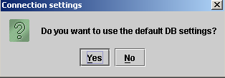

Here click on YES
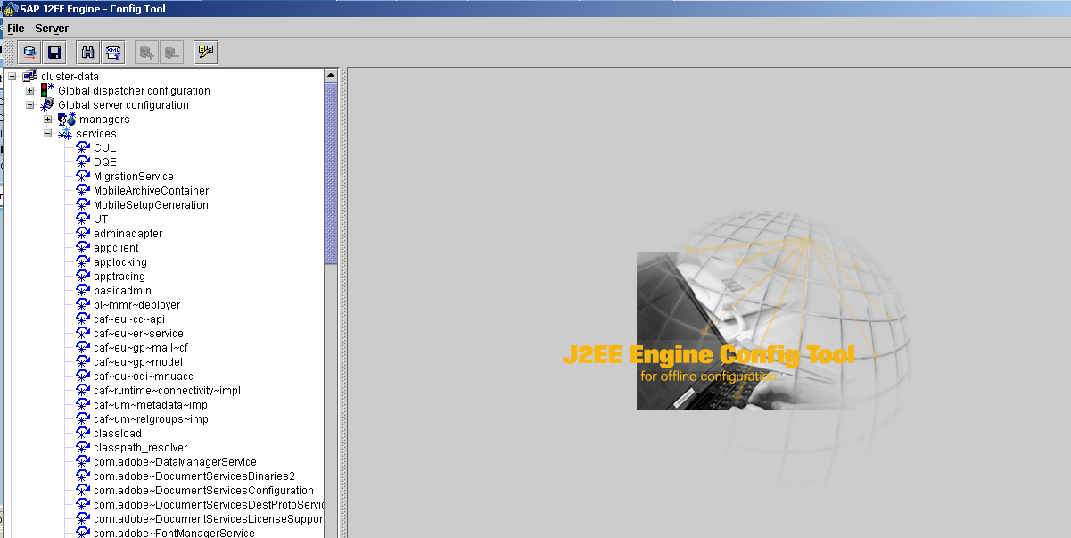

It display this window

Go to Global server configuration-→servies-→com.sap.security.core.ume.servies

Brand Image Path and Brand text Path
D:\usr\sap\BPE\DVEBMGS00\j2ee\cluster\server0\apps\sap.com\irj\servlet_jsp\irj\root\portalapps\com.sap.portal.runtime.logon\layout

Here past branding_image and branding_text these images just change images only name should be same. No problem name not mandatory.

Here select
Ume.logon.branding_image
Ume.logon.branding_text
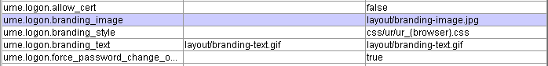

Like this click on Set Button
Same as Ume.logon.branding_text also

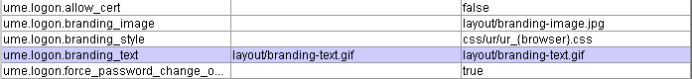

Next Restart the Server it will effect in portal

O/P
